Project Design Phase
Proposed Solution
Date | 04 September 2026
Student Name | Pulibanti Tejavani
Project Name | Metro Ticket Generating System
Maximum Marks

Proposed Solution
The proposed solution is a ServiceNow-based Metro Ticket Generating System designed to simplify digital metro ticket booking. A custom Metro Station Details table stores station information, while a Book A Metro Ticket Service Catalog item provides the required booking variables. The system uses station references for source and destination selection, Catalog Client Scripts for automatic fare calculation, and UI Policies to control field visibility and mandatory behavior. A custom Metro QR Widget generates and displays a QR-based digital ticket after submission. The solution provides a structured and user-friendly booking process through the ServiceNow Service Portal.

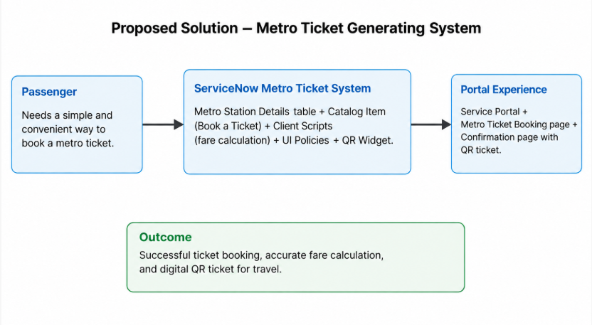
Figure 2: Proposed solution representation for the Metro Ticket Generating System.
S.No. | Parameter | Description
1 | Problem Statement | Metro passengers need a convenient and reliable way to select journey details, calculate fares, and obtain a valid digital ticket.
2 | Idea / Solution description | A guided ServiceNow Catalog-based metro ticket booking system with station selection, automatic fare calculation, payment handling, and QR ticket generation.
3 | Novelty / Uniqueness | Combines ServiceNow Catalog configuration, custom station data, dependent form behavior, client-side fare automation, UI Policies, and a QR-code widget.
4 | Social Impact / Customer Satisfaction | Reduces manual effort during ticket booking and provides passengers with a faster, clearer, and digitally verifiable ticketing experience.
5 | Business Model / Revenue Model | The system is intended as a digital metro service solution; no direct revenue model is required for the project implementation.
6 | Scalability of the Solution | The system can be extended with more stations and routes, integrated payment gateways, SMS/email notifications, advanced ticket validation, and travel analytics.

